**Shopping Cart - Architecture**

Shopping Cart is an Ecommerce application and it’s also considered as distributed applications, as they typically run on multiple servers and are accessed by users from various locations. The choice of the server is one of the important factor to determine the success of an E-commerce application and dedicated servers are considered as the optimal solution to these platforms. Dedicated servers are the choice for e-commerce applications, focusing on reliability, performance, security and scalability

**Benefits of Dedicated Servers**

* **Enhanced Performance**
* **Improved Security**
* **Scalability**
* **Reliability and Uptime**
* **Customisation**

**Recommendations**

1. Service Fabric – A more flexible architecture that can be implemented on any operating system or any cloud platform. Service fabric is container orchestrator for both Windows and Linux. Combination of Windows server containers and service fabric provided solutions for E-commerce API’s that didn’t require refactoring the code. This features allows application to work with API’s developed in different framework’s by deploying container services deployed on all nodes in the cluster. Actual implementation involves hosting application in containers and by adding new micro services

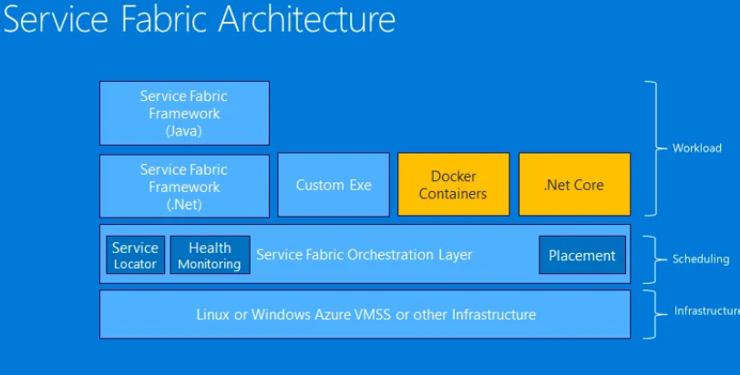

1. Azure Virtual Machines offers a range of networking capabilities that enables connectivity, security and high level availability for the hosted applications. Effective load balancing rules and customisation of resources (Memory, CPU) achieves scalability and reliability.

